21-04-2024

EFS Hands on

Common or Shared Storage in the AWS >>>>>

1 - EFS >>> Linux

2 - FSx >>> Linux && Windows

3 - EBS >>> Not supporting t2.micro >>> io2 >>>>

https://docs.aws.amazon.com/ebs/latest/userguide/ebs-volume-types.html

Common or Shared Storage in the AWS

Lab 1 >>> EFS for Linux

Lab 2 >>> FSx for windows

------------------------------------------------------------------------------------------------------------------

Lab 1 >>> EFS for Linux

Step 1 > Crate a Dedicated SG with NFS port number (2049)

Outbound should be all traffic

Click on create Security Group

Step 2 > Launch a EFS by using above SG

Go to Servies >> Storage>> Click on EFS

Name >>> Mahesh-EFS-21-04-2024

Then click on Customize

File system type >>> Regional

Automatic backups >>> Disable

Encryption >>> Disable

Leave all the options as it is >>> Next

Choose your VPC where you have created your SG

Remove all the Default SG at the bottom and attach your SG that you have created above

Cross verify all your AZ are selected, and your Dedicated SG is attached at Network Access Step

Click on next

File system policy - optional >>> Next

Review and Create

Make sure that status is "Available"

Click on EFS file system

Now click on to see the commands

Launch EC2

Choose 2 EC2 instances

Step 3 > Launch a Linux EC2 if not already

OS >>> Amazon Linux

Go to Custom VPC , Choose VPC and Public sunbet and

Enable Public IP

Choose your VPC where you have Launched your above SG and EFS

Choose Public Subnet

SG - Default

Leave all the options as it is

Both EC2 Instances are Launched

Step 4 > Make sure it has NFS(EFS) Port number attached (SG) in both the instances .

And save it

Go to second EC2

Click on Save

Step 5 > Login to the OS >> Install NFS Utility

sudo su

yum install nfs-utils

######## NFS utility Installation need to install in both the EC2 Instances

Step 6 > Do the host entry

######## host entry

vi /etc/hosts

## Syntax

<IP address of your Mount Target> <EFS DNS> <EFS without FQDN>

## Get the above details from the EFS >> Attach

Example -

10.0.0.70 fs-02d891831af02f32f.efs.eu-central-1.amazonaws.com fs-02d891831af02f32f

Our Syntax

Copy IP address

10.0.0.45

Then go to mount via DNS   
copy DNS

10.0.0.70 fs-02d891831af02f32f.efs.eu-central-1.amazonaws.com fs-02d891831af02f32f

10.0.0.45 fs-015d2e16f74619186.efs.ap-south-1.amazonaws.com fs-015d2e16f74619186

Step 6 > Do the host entry

######## host entry

Press insert

Copy the entry

10.0.0.45 fs-015d2e16f74619186.efs.ap-south-1.amazonaws.com fs-015d2e16f74619186

Save the file as

Pres ESC

Type :wq!

Go to Second EC2 Instacne

Copy the Syntax

Press Esc and :wq! To save

##########Mounting of your EFS

## Syntax

mount <EFS DNS>:/ /mnt

example

mount fs-02d891831af02f32f.efs.eu-central-1.amazonaws.com:/ /mnt

Step 7 > Try to mount EFS

example

mount fs-02d891831af02f32f.efs.eu-central-1.amazonaws.com:/ /mnt

Actual command

mount fs-015d2e16f74619186.efs.ap-south-1.amazonaws.com:/ /mnt

Now run the syntax

Mounted Successfully in one server now same syntax copy in second server

mount fs-015d2e16f74619186.efs.ap-south-1.amazonaws.com:/ /mnt

Successfully Mounted in Second server also

Step 8 > Test your EFS is working as shared storage or common storage

Create a folder mahesh in the EFS

Type the command

cd /mnt

mkdir mahesh

Now go to send server

Mahesh folder can be seen from both the servers

Now unmount the EFS

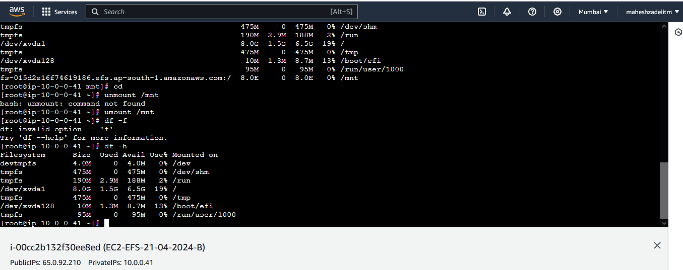

**umount /mnt**

**Now Delete the EC2 Instances, EFS , Security Group and clear the Lab.**

**Go to send server and type history command**

Pls check EFS Hands on and confirm .

Thanks